**Learning Word embeddings**

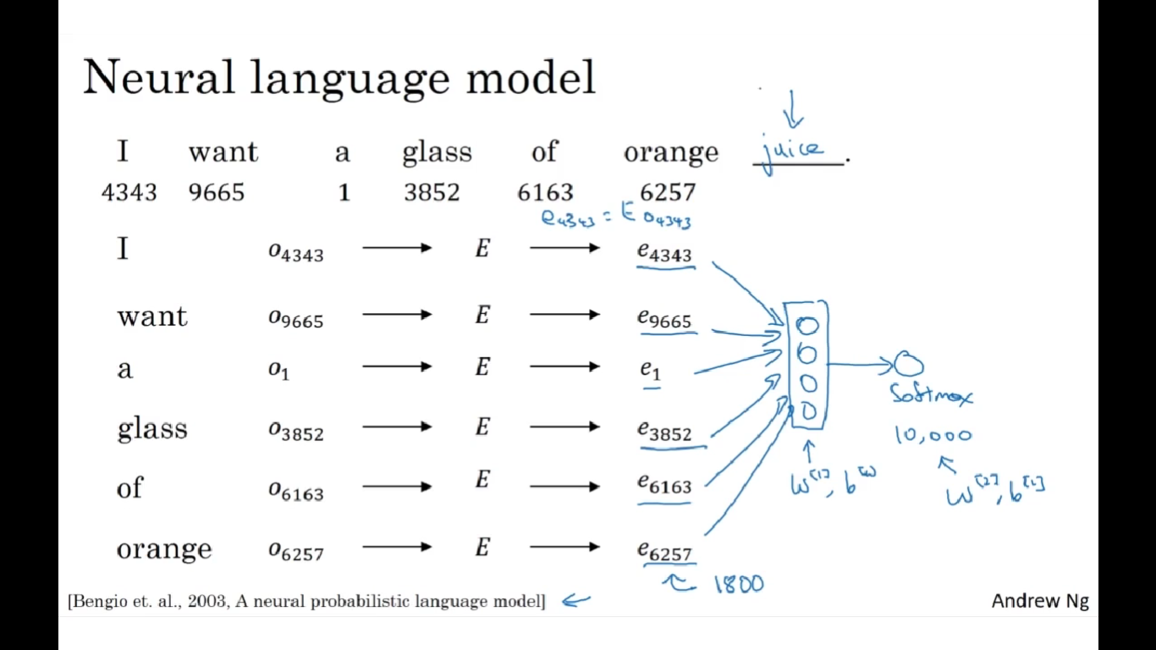

Can use only last 4 parameters to the NN to predict the next word

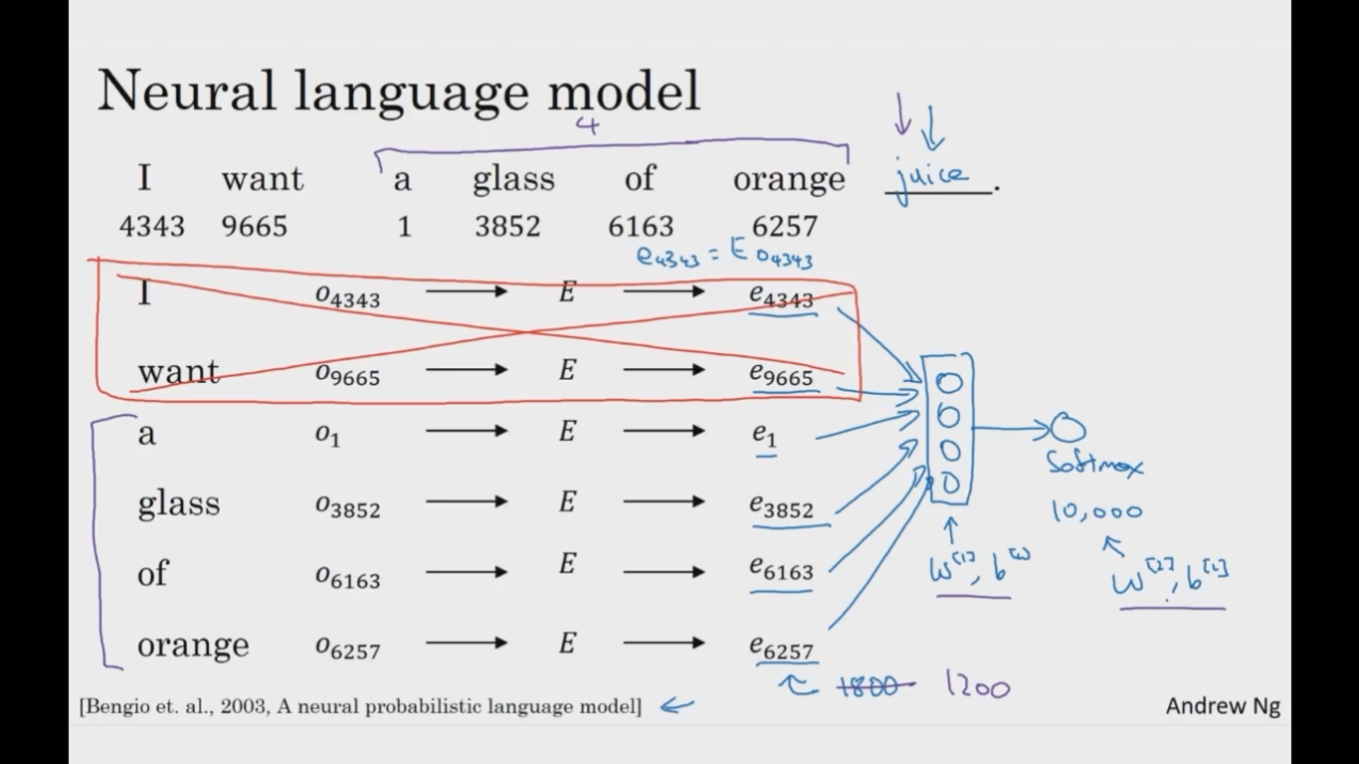

Parameters are E, weights and biases(in orange)

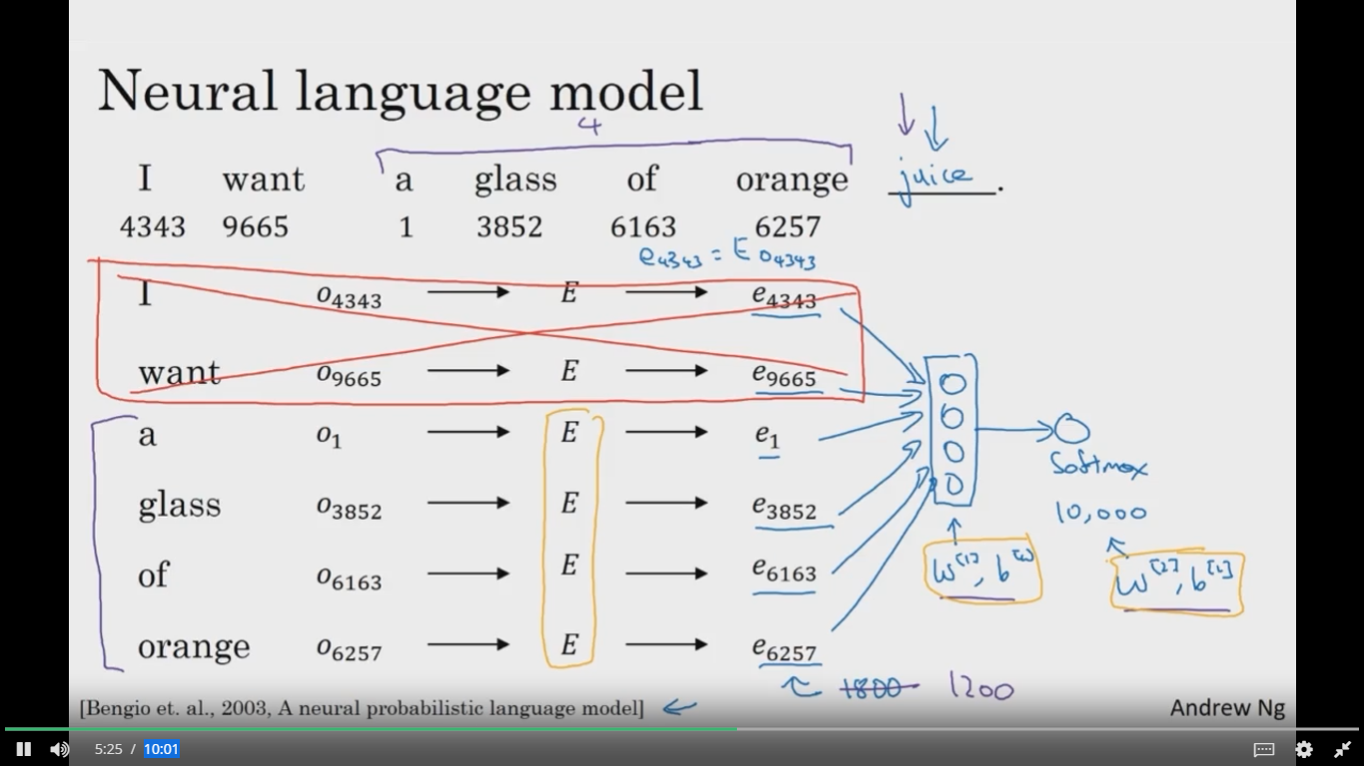

if you really want to build a language model, it's natural to use the last few words as a context. But if your main goal is really to learn a word embedding, then you can use all of these(in the curly braces) other contexts and they will result in very meaningful work embeddings as well.

